**Experiment No. 2.3**

**Student Name: Rishav Kumar UID: 22MCC20039**

**Branch: MCA - CCD Section/Group: MCD-1/ Grp A**

**Semester: III Date of Performance: 9th Oct 23**

**Subject Name: DevOps Process Automation Lab Subject Code: 22CAP-745**

1. **Aim/Overview of the practical:**
2. Install and configure TeamCity.
3. Make sure you fork the SpringPetClinic repository in your GitHub and connect that repository with TeamCity.
4. Create a new project via TeamCity dashboard and build all the 9 goals of Maven.

**Code for practical:**

**A.**

* Open JetBrains website and search Teamcity and download.
* Open installer and click on next and select path of software.

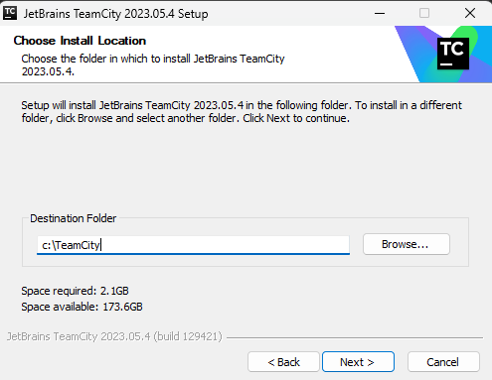

* Select port for localhost on which it will be 8111 by default.
* Click on use system user and click on ok.
* Run Teamcity on localhost:8111

**B.**

* Open Github and fork repository.
* Open ***Teamcity > Projects > New.***
* Click on from a Repository and enter github repository link.

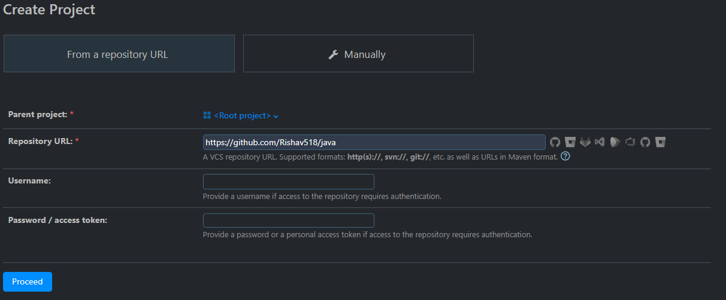

* Enter username and password if repo is private.
* Click on proceed.
* Enter name and branch and click on create button

**C.**

* Click on Build steps from left sidebar and click on add and search maven.
* Add build step name as Build and enter all 9 goals of maven.

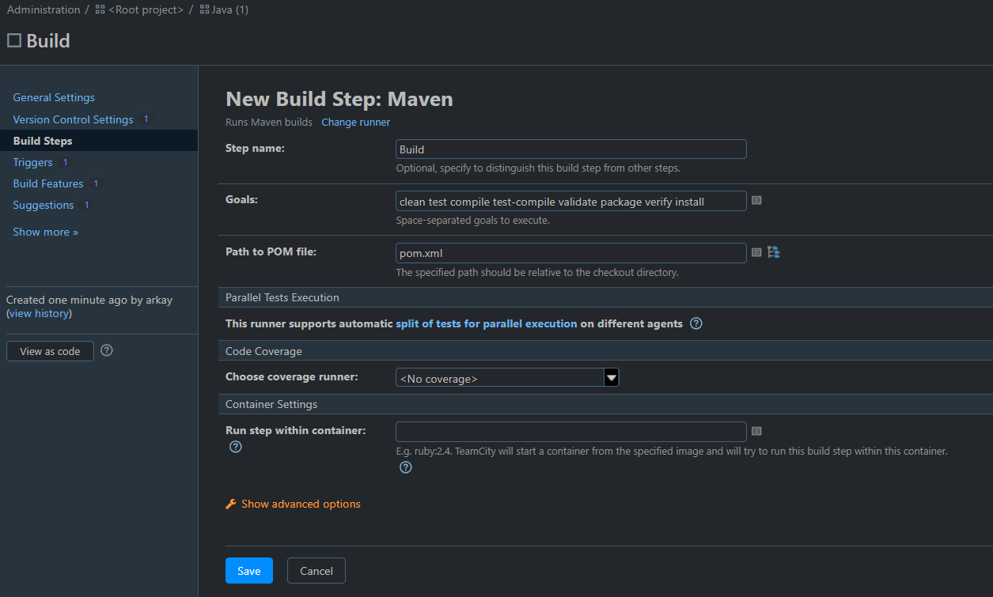

* Click on save and click on run.
* Project will be build in some moments.

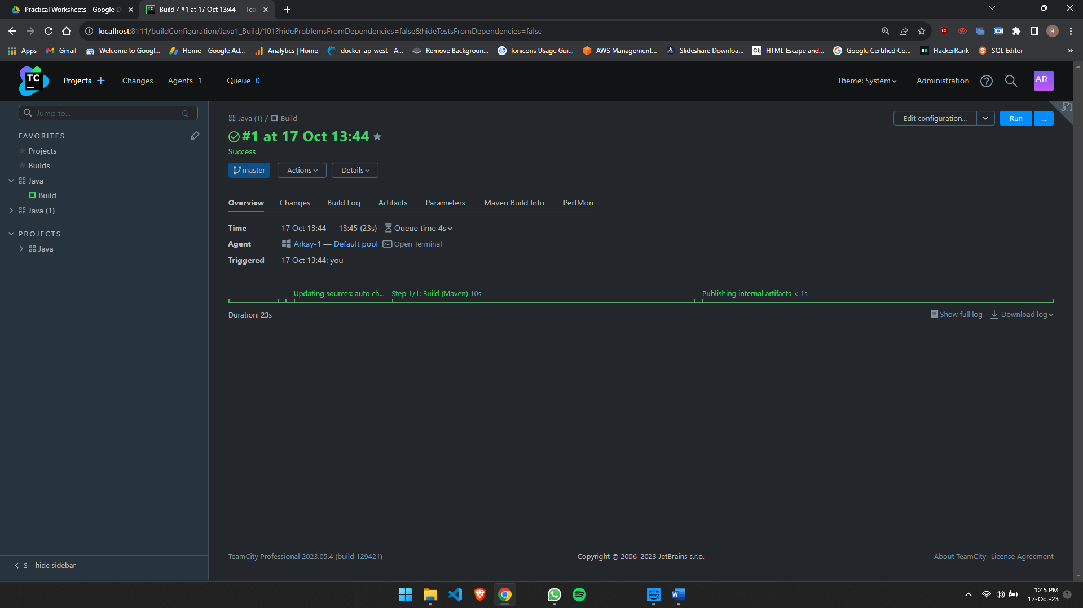

**************************************** **THE END** ***********************************************